Overview
This document provides contractors with clear guidance on what is required for participation in the WGOS1 Prevention Audit, including an explanation of the PDSA (Plan–Do–Study–Act) cycle and the specific actions required at each stage. This information aligns with the audit protocol and supports contractors in meeting WGOS contractual requirements.
The audit has been designed in partnership with Health Boards and Optometry Wales. It is intended to support contractors in meeting the requirements of the WGOS1 and 2 clinical manual with regard to 1) Health messaging and 2) documentation of directed questions.
Contractors must complete one audit per practice site (Health messaging) and for each optometrist (inclusive of locums and students) working within that practice site (Directed questions). Completion is mandatory for QFO payment, and non-completion may result in the £1300 QFO payment being reclaimed. Contractors with mobile contracts must complete the audit for each Health Board area in which they have a contract and receive a QFO payment.
The audit provides an important opportunity to strengthen the prevention focus within WGOS, improve the consistency of clinical documentation, enhance patient experience, and demonstrate quality improvement through the PDSA cycle. Contractors are encouraged to approach the audit as a constructive and reflective exercise that supports high-quality, prevention-focused primary eye care across Wales.

Purpose of the Audit
The WGOS1 Prevention Audit evaluates:
- Health messaging displayed within optometry practices.
- Documentation in WGOS 1 and 2 patient records of directed questions (smoking/vaping, diabetes risk, time outdoors for under-15s).
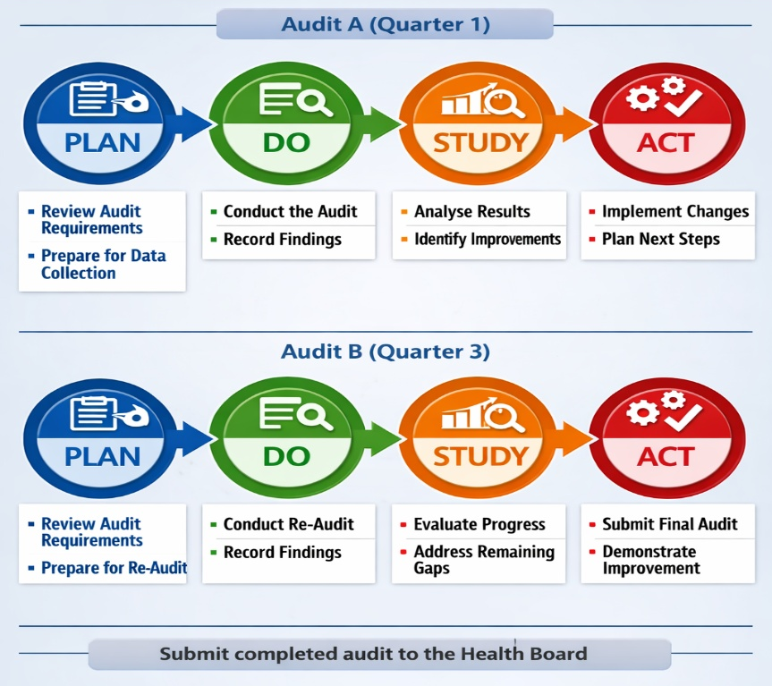
This audit supports prevention-focused care, strengthens clinical governance, and contributes to WGOS contract assurance.

The Plan-Do-Study-Act (PDSA) Cycle
The audit follows a PDSA quality-improvement cycle, enabling contractors to review current practice, implement improvements, and demonstrate change over time.

PDSA A

PLAN (June 2026)
What contractors need to do
- Review the audit requirements for Part A (Practice Environment) and Part B (Clinical Records).
- Familiarise yourself with the Audit tool
  - Instructions
  - FAQs
  - Health messaging example
  - Directed questions example
- Identify who in the practice will complete the tool (someone who is familiar with the interpretation of clinical records.
- Ensure access for this person to:
  - The audit tool
  - Ten WGOS1 and 2 records per optometrist working in April 2026 (w/c 6th April the first 10 records for each optometrist).
- Review the WGOS Clinical Manual requirements for:
  - Directed questions.
  - Prevention and health-promotion expectations.
Outputs
- A clear plan for completing ‘Health messaging’ and ‘Directed questions’ parts of the audit in both Quarter 1 and Quarter 3.

DO (June 2026)
Part A: Health messaging Audit
- Conduct a structured walk-through of the practice.
- Assess the presence, visibility and relevance of health-promotion materials.
- Record findings using the audit checklist.
Part B: Clinical Record Audit
- Select ten WGOS 1 and 2 records per optometrist working in April 2026 (w/c 6th April the first 10 records for each optometrist).
- Review each record for evidence of directed questions.
- Document findings in the audit spreadsheet.
Outputs
- Completed Part A (Health messaging and Directed questions) audit tool.
- Retain the audit tool at this point, you do not need to submit to the Health Board or NWSSP.

STUDY (July 2026)
What you need to do
- Review your audit results.
- Identify areas where standards are met and where improvement is required and engage with resources and support as required
- Reflect on:
  - Gaps in health messaging.
  - Inconsistencies in documentation of directed questions.
  - Any training or resource needs.
Outputs
- Completion of ‘Action required’ section of the ‘Health messaging’ and ‘Directed questions’ audit tool
- Plan for action/implementation of changes required.

ACT (July/August/September 2026)
What you need to do
- Implement the improvements identified in the Study phase.
- Examples include:
  - Updating or repositioning health-promotion materials
  - Adjusting record templates
  - Staff training on directed questions
- Prepare for the Quarter 3 re-audit.
Outputs
- Documented actions taken
- Evidence of improvement actions for Q3 re-audit

PDSA B

PLAN (October 2026)
What you need to do
- Review the audit requirements for Part A (Practice Environment) and Part B (Clinical Records).
- Familiarise yourself with the Audit tool
  - Instructions
  - FAQs
  - Health messaging example
  - Directed questions example
- Identify who in the practice will complete the tool (someone who is familiar with the interpretation of clinical records.
- Ensure access for this person to:
  - The audit tool
  - Ten WGOS 1 and 2 records per optometrist working in October 2026 (week to be confirmed by November 2026)
Outputs
- A clear plan for completing ‘Health messaging’ and ‘Directed questions’ parts of the audit during quarter 3.

DO (October/November 2026)
What you need to do
Part A: Practice Environment Audit
- Conduct a structured walk-through of the practice.
- Assess the presence, visibility and relevance of health-promotion materials.
- Record findings using the audit checklist.
Part B: Clinical Record Audit
- Ten WGOS 1 and 2 records per optometrist working in October 2026 (week to be confirmed by November 2026)
- Review each record for evidence of directed questions.
- Document findings in the audit spreadsheet.
Outputs
- Completed Part A and Part B of the audit tool.

STUDY (Quarter 3)
Identify areas still requiring improvement and note on the relevant sections of the audit tool

DO
Submit completed audit tool to the HB electronically by the 12 noon on the 14th of December 2026

